Lesson Topic
Rationing

State Standards
2.OA
7.NS

Lesson Goal

Students will use basic math skill to plan a menu

Relation to USS Kidd

While WWII was happening, rationing was occurring on the Homefront.

Objectives
Students will plan a menu for a week during WWII rationing

Materials needed for lesson
- Charts
- Pencil, paper

Lesson
The United States has been a land of prosperity. The concept of governmental rationing will d foreign to students. On the Homefront in the 1940s people had to deal with food rationing during World War II. Food rationing started in the spring of 1942. The government realized that something had to be done to control the supply and demand of certain foods. Food had to be shipped to the troops fighting overseas. This created a shortage in the United States. Rationing was instated to ensure that wealthy families couldn't just buy large quantities of foods that were in short supply at a higher price. This meant that every family, rich or poor, here on the home front would be affected by food rationing. Food rationing came to an end in 1946.

Foods Rationed on the Home Front
Some of the food items that were rationed during World War II were items like butter, sugar, meat, canned fruits and vegetables, cooking oil, tea, coffee, dried beans, ketchup, and baby food.
A point system was used to determine how much of each item a family could purchase. The number of food coupons your family would receive each month depended on how many people were in your family. Each family received both red and blue stamps with a certain number of points on them.
Red points were for meat, butter, cheese, sugar and oils.
Blue points were for canned foods.

People had to have enough points for each food as well as the money required to purchase a rationed food.
Fresh fruits and vegetables were not rationed but some were in short supply. This prompted the government to launch a victory garden campaign. Victory gardens were grown all over the country by families that may not have gardened before. The fruits and vegetables helped families have plenty of food during the war.

Planning WW II Rationing Menu
Students will plan a week-long menu using foods that were rationed in World War II.
Give students a certain number of red and blue stamps that will last a week as well as money needed to purchase the needed foods in order for a family of four to eat for a week. Students will plan breakfast, lunch and dinner for a seven-day period. Meals should be nutritious. You may wish to post a food group chart from the 40s or just use the food guide pyramid to help kids plan healthy meals.
Any unrationed foods can freely be added to the menu, such as fresh fruits or vegetables that are homegrown in a victory garden.
Each person will have 16 red stamps and 48 blue stamps each week. This would be 64 red stamps and 192 blue stamps for a family of four. You could use these numbers for students to plan their meals.
Use the chart of rationed foods and the number of points needed to buy them and put the chart on display for kids to use while planning their menu. The students will list the point value by the food listed on the menu and tally them up for each day as well as the week. Use this World War II food rationing chart with each page showing the points per rationed food item. This makes for lessons in both math and history.
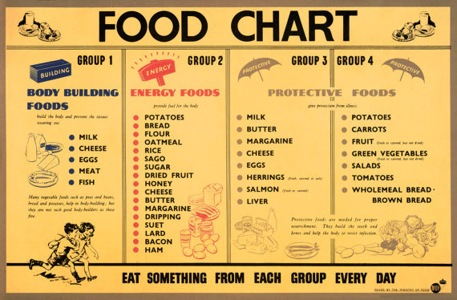

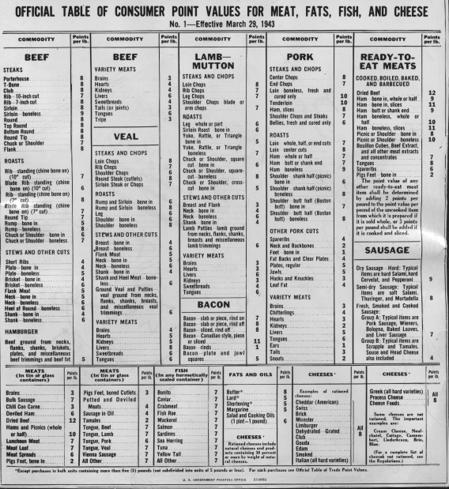

Assessments
Students will create a menu for a week

